Geometry: Unit 8, Lesson 7
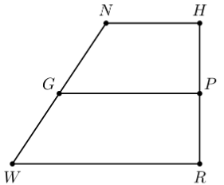
- Trapezoid $NHRW$ with midsegment $\overline{GP}$ is shown. $HP=x+4$, $PR=4x-2$, $GP=12$, and $NH=5x-2$. What is an equation that can be used to find the value of $x$?

$$x+4=4x-2$$

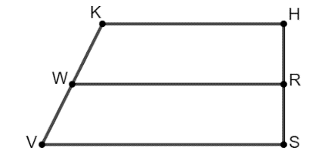
- Trapezoid $KHSV$ with midsegment $\overline{WR}$ is shown. Is the statement $\overline{WR}=\frac{1}{2}(\overline{KH}+\overline{VS})$ true?

Yes
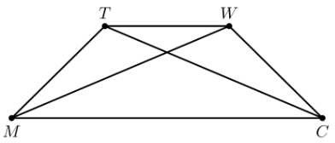
- Isosceles trapezoid $TWCM$ where $m∠TMW=\left(6x-7\right)°$, $m∠MTW=\left(13x+11\right)°$, $m∠MWC=\left(7x-6\right)°$, $\overline{TM}=(2x+5)$, and $\overline{WC}=\left(3x-2\right)$ is shown. What equation is needed to find the value of $x$?

$$2x+5=3x-2$$

